

*September 30, 2024*

Wells - Barkerville Elementary

School Growth Plan

2024-2027

*School growth plans are aligned with the District's* [*Strategic Plan*](https://bcsd28.civicweb.net/document/70641/) *with priority measures represented in the Framework for* [*Enhancing Student Learning Report*](https://bcsd28.civicweb.net/document/70521/)*.*

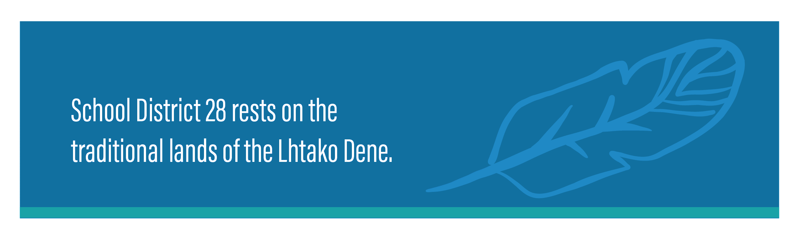



What makes Wells-Barkerville great?

* Small class size
* Friendly supportive environment
* Community involvement
* Mentorship/leadership – older students help the younger students develop skills and traits to be successful citizens
* Many special events: Remembrance Day, Christmas Play
* Commitment and support of parents
* Opportunities for many small group discussions
* Focus on place-based learning, outdoor education

PAC

Wells-Barkerville has an active Parent Advisory Council that supports students and staff. Our PAC meets every fourth Tuesday of the month.

**SCHOOL**

**INFORMATION**

Wells-Barkerville Elementary is located in Wells, BC and is part of School District #28 (Quesnel). It is a small school with a multigrade classroom of students from Kindergarten to grade 7.

Our students have many year-round opportunities for outdoor learning, place-based learning and are very involved in the community arts programs.

We know that we continue to need to gives students strategies to further their learning and to regulate their emotions.

We continue to balance the challenges of a multi-grade classroom and are concentrating our energies on providing our students the skills they need to be successful.

**OUR SCHOOL**

THE STORY/JOURNEY

SUPPORTIVE SPACES

At Wells-Barkerville our learners will be able to identify and communicate how they and others are feeling and practise strategies that support self-regulation and healthy decision making.

Belonging – class buddies and mentorship, leadership, class jobs, talking circles.

Communication – regular parent communication through email, phone, and after school conversations.

Mental Health and Well-being – Second Step, growth mindset

Outdoor Education – understanding that learning in nature reduces anxiety and improves overall well-being, land-based, experiential learning happens as much as possible.

Differentiation – “just right” access points for all students, meeting them where they are to build confidence and self-efficacy.

ACTIONS/STRATEGIES:

RATIONALE

We believe inclusive, caring schools are fundamental to a thriving community. True inclusion ensures students and staff see themselves represented and feel as though they belong in the space, are connected to the other members of the school and are able to access the curriculum they are engaging with.

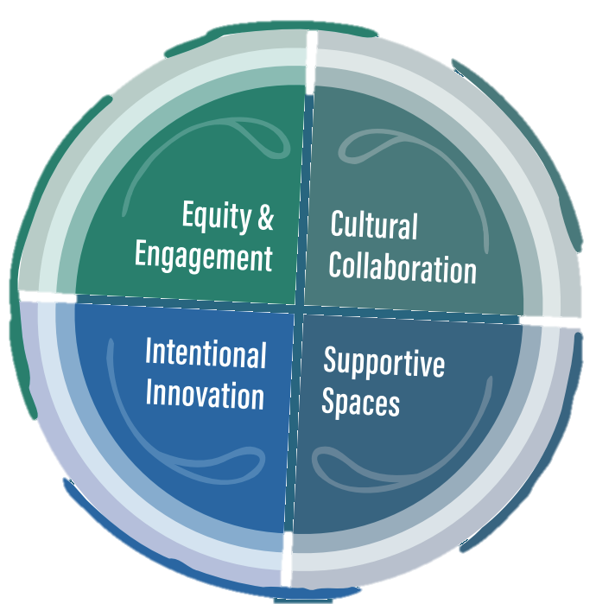

MEASURES:

Observations

Data from school district surveys is masked due to the small number of students.

SPEAK TO THE DATA:

This year we will be conducting a belonging survey to better understand the connections students have with our school. Wells-Barkerville is a small school and has a strong sense of community within the school and the community of Wells.

Data from Student Learning Survey and the Midlis masked.

EQUITY & ENGAGEMENT - LITERACY

At Wells-Barkerville, our students will demonstrate increased academic growth in literacy.

Support students to attain the skills to be successful on the Provincial Literacy Assessment

Develop and utilize a Literacy Framework inclusive of Tier 1, 2, 3 interventions

Immersion in a variety of literacy opportunities – independent “just right” reading every day, guided reading, buddy reading, side by side reading, read alouds, UFLI, writer’s workshop and author’s circle.

ACTIONS/STRATEGIES:

RATIONALE

We are preparing learners for a world that we do not yet know. A focus on intellectual, human and social, and career development we will provide meaningful learning opportunities for all students to achieve their goals.

MEASURES:

MyEd Data English Language Arts Data

Reading Level Data (PM Benchmarks and Fountas & Pinnel)

Foundational Skills Assessments

Literacy Learning Pathways



SPEAK TO THE DATA:

Our June 2024 English Languaage Arts Data shows that 83% of our students meeting grade level expectations for speaking, listening, reading and writing.

Reading Level Data from June 2024 shows that 75% of our primary students and 75% of our intermediate students are meeting grade level expectations of reading fluency and comprehension.

We look forward to seeing more progress in the coming years as we develop Tier 1 supports to continue to build students’ reading, writing, speaking and listening skills.

EQUITY & ENGAGEMENT - NUMERACY

At Wells-Barkerville, our students will demonstrate increased academic growth in numeracy.

Use comprehensive and consistent numeracy assessment practices to guide planning and deepen understanding

Number talks, Esti-Mysteries, Esti-Clipboards

Rich Math routines

Math games and centres

Hundred Day

Guided Math

IXL

Counting Collections

ACTIONS/STRATEGIES:

RATIONALE

We are preparing learners for a world that we do not yet know. A focus on intellectual, human and social, and career development we will provide meaningful learning opportunities for all students to achieve their goals.

MEASURES:

MyEd Data

Learning Pathways

SNAP Math assessments (Spring 2025)



SPEAK TO THE DATA:

June 2024 MyEd Mathematics data shows that 83% of our students in grade 1 to 7 are meeting grade level expectations in Mathematics.

We look forward to having a district-wide assessment tool to get a better picture of our students math skills.

This year we will be focusing on using the SNAP Math Assessment to look at number sense skills. In the coming years, we will be using SNAP to assess other math skills.

CULTURAL COLLABORATION

At Wells-Barkerville, our students will continue to engage in cultural experiences with local Indigenous communities to build a learning environment free from racism and discrimination and to imbed Idigneous practice, education and history in our curriculum and lessons.

Language – District Language lessons, bulletin boards, language posters,

Local Knowledge: bannock, Lahal, jigging, dancing, beading, history, guest artists, crafts, land and animals.

Orange Shirt Day, National Indigenous Peoples Day, Truth and Reconciliation Week

Indigenous texts and resources.

With guidance of First Peoples Principles of Learning, enhance learning opportunities through place-based, experiential education in and around the community and local environment.

ACTIONS/STRATEGIES:

RATIONALE

While the results for Indigenous students continue to improve, gaps still exist between non-indigenous and Indigenous students. The results, together with the feedback from community consultation, highlight the need for the district to address these inequities of outcomes, by partnering with Indigenous communities to create safe and culturally responsive learning environments for the students free from racism and discrimination.



MEASURES:

Evidence of tolerance and diversity

Observations and anecdotal evidence.

SPEAK TO THE DATA:

 

SPEAK TO THE DATA:

At Wells-Barkerville we continue to embrace the First Peoples Principles of Learning and learn about the culture. Traditions and language of the local and national Indigenous Peoples.

Learning supports the well-being of the self, the family, the community, the land, the spirits and the ancestors.

Learning is holistic, reflexive, reflective, experiential and relational.

Learning involves recognizing the consequences of one’s actions.

Learning involves generational roles and responsibilities.

Learning recognizes the role of Indigenous knowledge.

Learning is memory, history, and story.

Learning involves practice and time

Learning explores one’s identity.

Learning involves recognizing that some knowledge is sacred and only shared with permission and/or in certain situations.

SPEAK TO THE DATA: